# Statistical Multipath Modelling

There is random number of multipath components, each with

* Random amplitude
* Random phase
* Random delay
* Random Doppler shift (effect of receiver’s moving at a particular velocity relative to the signal wave source on a wave frequency)

These random components are changing with time, which leads to **time-varying channel impulse response.**

**Time-varying channel impulse response.**

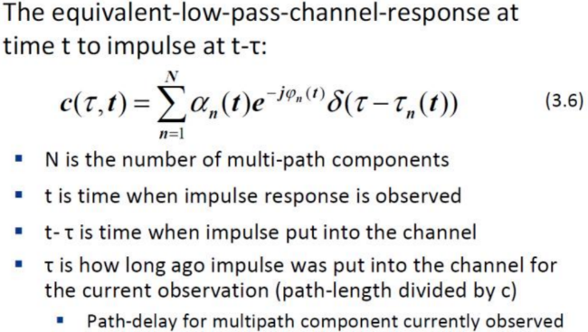

**c(τ,t)** is different in different environments

**Delay Spread**

Is a measure of the multipath richness of a channel – difference between time of arrival of the first significant multipath component (typically LOS component) and last multipath component.

This can be quantified by different metrics, but the most common one is **root mean square.**

**Power Delay Profile** has to be first determined – this is the intensity of signal received through a multipath channel as a function of time delay.

Statistical Modelling methods

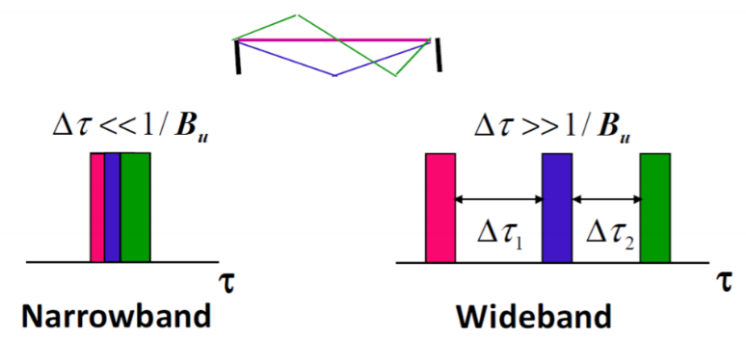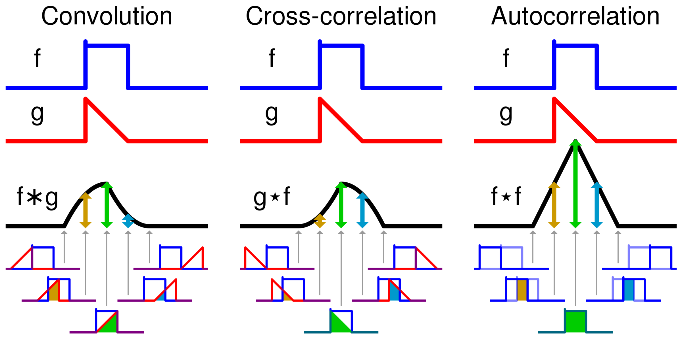

**Scattering Function of Wideband Channl**

τ represents the impulse response with a given multipath delay and t represents variations in time

**Sc** (Scattering Function) is then calculated by taking a Fourier transform of **c(τ,t)** relative to t. Rho captures the Doppler spread of the channel

* Scattering function characterizes the RMS delay and Doppler shift, which are key parameters for system design

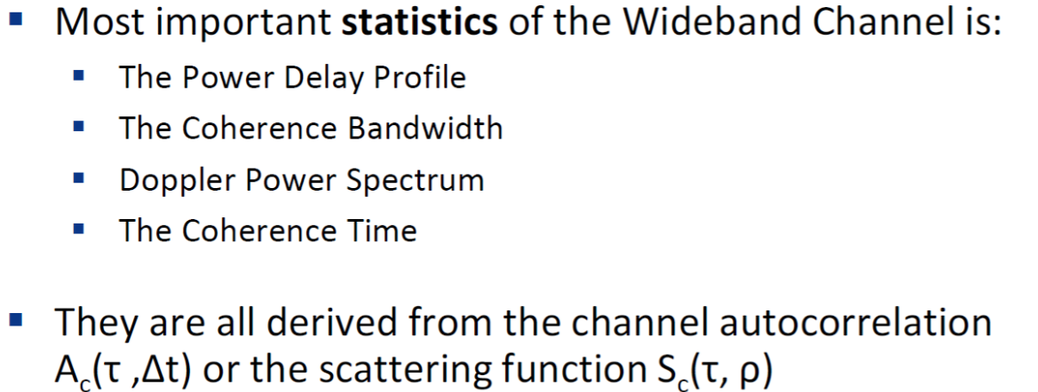

* Wideband fading channels are much more complicated to deal with than narrowband fading channels (e.g.4G LTE vs WSN)
* Power Delay Profile is the average power associated with a given multipath delay
* Coherence bandwidth of channel (Freq Domain) is an inverse of delay spread describing a frequency span with a constant channel
* Doppler spread defines maximum non-zero Doppler (Freq Domain), its inverse is coherence time (time domain) which is the time duration over which the channel impulse response is considered to be NOT varying

**In-Phase and Quadrature of Narrowband Channel**

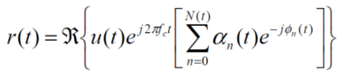When Narrowband channel is modelled we assume **maxm,n** delay spread | τn(*t*) – τm(*t*)|<<1/BWSIGNAL

The received signal is given by

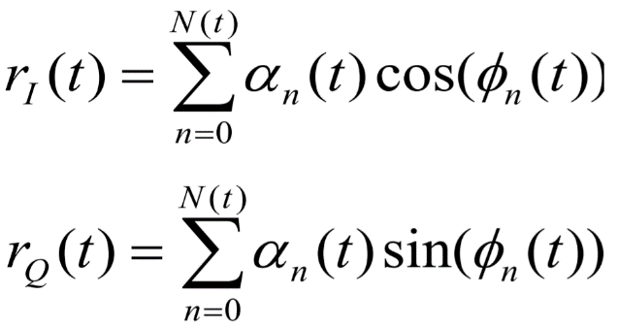For non-line-of-sight components, this can be approximated through in-phase and quadrature signal components.

If  (time of arrival function) is uniform, the in-phase and quad components are mean zero, independent and stationary. From Central Limit Theorem we know that received signal is characterized by its mean, auto and cross correlation

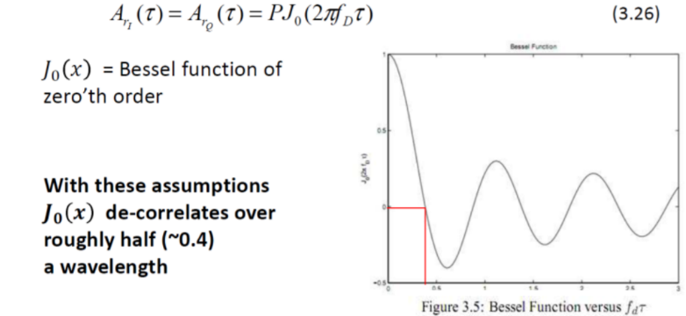

If we also assume uniform angle of arrivals of multipath components, components will have no cross correlation and autocorrelation will follow Bessel Function of zeroth order.

* Uniform scattering makes autocorrelation of in-phase and quadrature follow Bessel Function – signal components de-correlate over half wavelength, cross-correlation is 0.
* Power Spectral Density of received signal has bowl shape centered at carrier frequency, which is very useful for simulations
* Fading distribution depends on environment; Rayleigh, Ricean & Nakagami are all common
* Markov model approximates fading dynamics